General Announcements:
Dates to Remember
- Fall APO LEADS Day at Illinois State University - September 29
- Last day to turn in Dues - October 2 ($40)
- Fall Section Service Project at University of Illinois at Urbana-Champaign - October 20
- Fall Section 50 Conference at Parkland College - November 2-3
- National Service Week - November 4-10
- Initiation - November 13
- Last Meeting - December 4

WELCOME NEW PLEDGES! :)
Appointed Positions:

Student Senate Liaison - Andrea Kerwin
Webmaster - Thomas Simmons
National Service Week Chair - Abby Mills
Historian - Annmarie Gast
Chaplain- Jason Murphy
Alumni chair- Ellen Cornelius

Voting -
National Convention voting delegates - December 27-30, 2012 in Anaheim, CA

Nominations -
Fall Section 50 voting delegates - November 2-3, 2012 at Parkland College in Champaign, IL

Re-approval of Advisors

Service Events:
- Posters for Car Wash: 09/20
Blood Drive: 09/20 in Hansen
- Marcfirst Car Wash!!!: 09/23. at Ace
Vote on where money goes
- Majors and Minors Fair: 09/26 in Main Lounge
- Peace Garden: 09/30 in the Garden
- Red Cross Blood Drive help: various dates and locations
- Immigration Project training tomorrow, September 19th, 6:30-9:30 at The Immigration Project Office
- Please return date survey about the EAC and Smart Sprouts at the end of chapter.
- Look for another Reading Buddies event on APO online soon.
Fellowship Events:
- La mission 09/19 at 7:30
- Comedian Michael Yo 09/22 at 8:00
- Sign up for active retreat October 26th/27th
Membership:
Vote on Janette Abassi for associate
Birthdays: Ellen Cornelius (09/19) and Iyinogooluwa Ajayi (09/20)

Meet your Brothers!
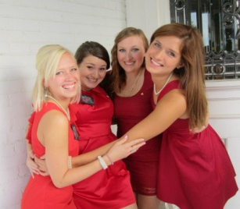
Ellen Cornelius
- Junior Undecided
- Her favorite TV show is Growing Pains
- She likes the movies, Out of Africa
and Harold & Kumar Go to White Castle
- She likes piglets
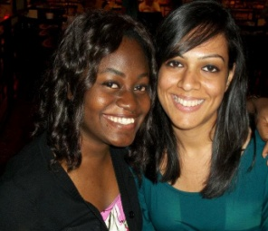
Iyinogooluwa Ajayi
- Junior Accounting Major
- She likes Criminal Minds and Vampire Diaries
- Her favorite book is Heaven’s Wager
- She likes Mission Impossible: Ghost Protocol
Zeeni Zaheer
- Sophomore English Writing Major
- She likes The Arctic Monkeys and The Strokes
- Her two favorite books: On the Road and A Tale of Two Cities
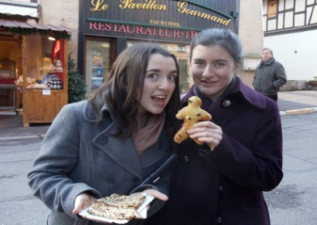
- Fun fact: She lives in Sarasota, FL
Katie Cannon
- Junior English Lit/Hispanic Studies Major
- Her favorite animal is a sloth bear
- Her favorite TV show is New Girl
- She likes the movies, Pride & Prejudice and Dodgeball

Meet your Pledges!
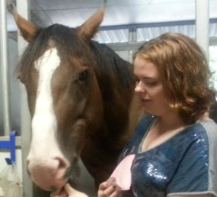
Corey Martin
- Sophomore Psychology Major
- Her favorite movie is August Rush
- She likes Criminal Minds
- Fun fact: She rides horses, and she has one named Charlie

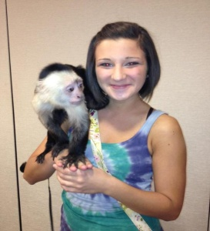
Jehona Osmani
- Sophomore Psychology Major
- She likes One Tree Hill
- She likes the Eli Young Band
- Her favorite book is The Great Gatsby
- Fun fact: Her name means echo/moon

